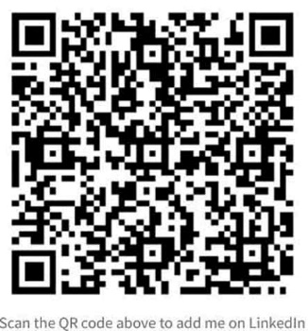 | BROKER APPOINTMENT AGREEMENT  Part I
1. Agreement No.
DD-MM-YYYY-TL-00X
2. Sellers’ Broker (full style and address)  Company: Shanghai Highwoods Ship Co., Ltd.  Legal representative: William Peng  Phone No.: +86 18217175747  Email address: info@shorefacility.com  Rm 3832 Building. 555, No.3111 Ring (W) Road Fengxian Shanghai China | 3. Sellers (full style and address)  Company:  Legal representative:  Phone No.:  Fax No.:  Email address:  Address:
4. Vessel  Name:  IMO number:  Gross tonnage: | 5. Price idea in USD
6. Commission: 5% of the selling price | 7. Preferable delivery of time/place:
It is mutually agreed on this date _DD/MM/YYYY that the Sellers appointed Sellers’ broker to Publicly/privately sell the mentioned ship at the good price. The selling process may take months and the sellers shall update the price in timely manner if there is any change. The sellers shall only through the Broker forward the ship selling price to the buyers introduced by the Broker. No matter how much the final price is, the sellers shall agree to pay the commission without any conditions and without any delay. The sellers shall assist the broker and his buyer to complete visual inspection.

This appointment agreement comes into force when both parties have signed and sealed electronically and exchanged the documents by email. The agreement remains effective unless one party officially noticed the other party to cease the appointment.

To encourage ship owners to benefit more from the broker’s SPRO agency service at China all ports, the sellers’ broker shall provide free SPRO agency service to the sellers’ whole fleet if the sellers’ signed annual ship Pollutant Cleanup agreement for the broker.

Signature and Company Stamp (Agent)  Date: | Signature and Company Stamp (Principal)  Date:

